For Immediate Release
31 YOUTH WIN IBJ GLOBAL COMPETITION
FOR JUVENILE JUSTICE

Geneva Switzerland, November 17, 2020. International Bridges to Justice (IBJ) announces the winners of its first ever Youth for Youth Justice Competition. 31 youth activists were awarded seed grants to increase justice for youth in prisons worldwide. Competition winners – who range in age between 16 and 29 years old – come from diverse countries including, Benin, Burundi, Cameroon, Colombia, DR Congo, India, Nigeria, Pakistan, Rwanda, Thailand, Togo, and Zimbabwe. They now join IBJ’s global movement of activists fighting for youth rights behind prison bars.

"Youth can and should be a powerful force in the fight for access to justice worldwide. IBJ’s Youth for Youth Justice Competition harnesses youth power to mobilize solutions to tackle the real injustices vulnerable incarcerated children face, from Cameroon to Colombia." - Noah Wong, 18, President of IBJ Youth

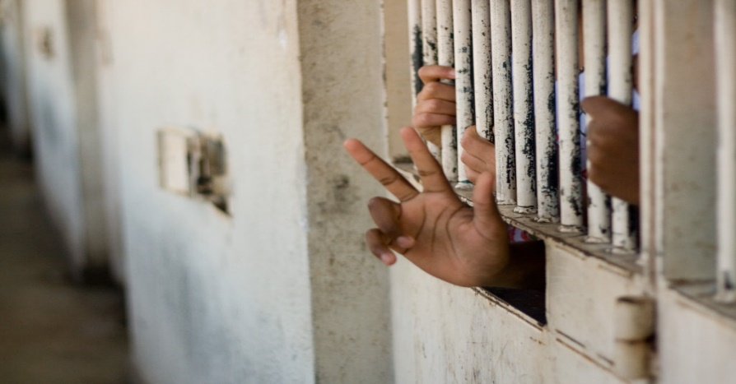
Global Crisis for Imprisoned Children. An estimated one million children are in detention around the world. Despite constitutional and legal provisions that ensure their rights, up to 85% of children are incarcerated with adults, leaving them vulnerable to violence and predatorial sexual abuse. Too poor to afford a lawyer, children often languish for months or years behind bars awaiting trial. With nowhere to turn, they face an uncertain and desperate future.

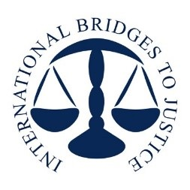
IBJ Youth for Youth Justice Competition winners will use award funds to create new solutions for incarcerated children. 25-year old Eulalia, a student from Colombia, is developing an app to help youth protestors alert others when they are being arrested, enabling lawyers to quickly intervene. 16-year-old Nita, a Thai high school student, is creating a game style app where users role-play a youth going through Thailand’s tough juvenile justice system – from arrest to sentencing. Both apps will be housed on JusticeHub, IBJ’s platform for the justice ecosphere. Judith, a third year law student in Burundi, is using award funding to set up an association specialized in support for incarcerated children. Key donors for the IBJ Youth for Youth Global Justice Competition include, Clarisse Morgan, John Jameson, Brian Rishwain, Mia Yamamoto, and the Oak Foundation.

About International Bridges to Justice (IBJ): With 20+ years’ experience in justice solutions, IBJ provides early access to lawyers for vulnerable accused, including children. To date, 31,000 IBJ legal defenders have provided skilled, no-cost legal assistance to 404,000 accused individuals around the world. Get involved here.

For more information and high-resolution pictures, or to organize visits to IBJ offices worldwide, please contact Andrew Ozanian, aozanian@ibj.org, www.ibj.org.

